$$Online Application for Reservation Desk:$$

Application Name : Online Reservation Desk

**Package Name:** com.itfrontdesk.reservation

**Description:** Students/Customers will be able to use online app and use it to Reserve the appointments with their providers (Events etc) at any time.

**2**

**1**

$$Flow :$$

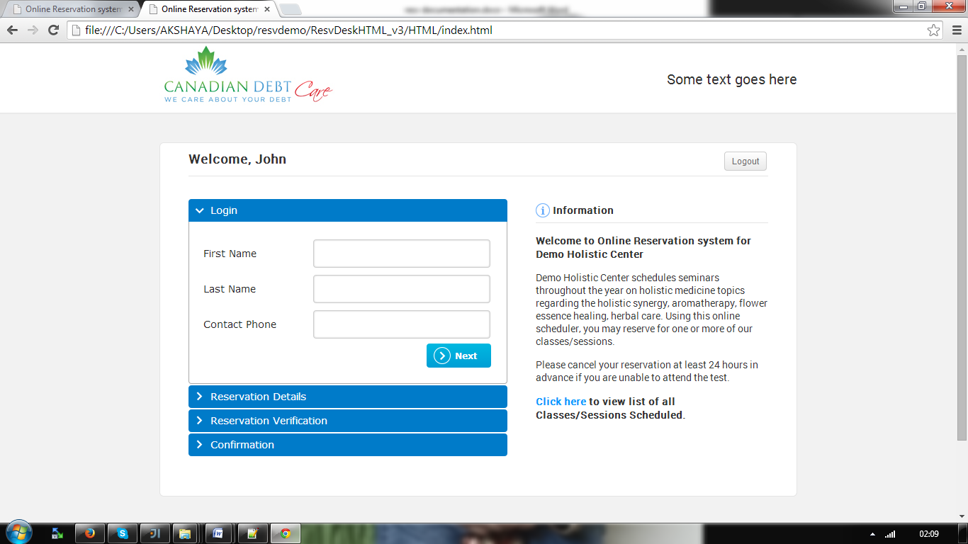

**3**

**5**

**4**

Online Reservation URL:

http://development.telappoint.com/resv/login.html?client_code=DEMOMEDG

**Get Client Info:**

**getClientInfo (String clientCode, String langCode):**

If no rows found, Show the error page to USER.

